
people & technology: powering transformation



HDE
Group Service Common Cache Design Document

draft

Submitted by:
Kanbay Inc. – 11/3/2006

This document outlines high-level design details of the common cache implementation of the Group Service.

Table of Contents
1. requirement 4
2. solution approach 5
Analysis: 5
Class diagram: 5

requirement

As part of Help Desk Enhancement (HDE) project a new service has been added to the CBOE software portfolio called ‘Group Service’.
The group service’s design intent is to initially provide group management services for hierarchies of user_Ids and “sub-groups”. These groups are defined to support the ability to enable/disable connectivity, logout, and cancel the orders for all User_Ids within a given group. While the HDE implementation focused on user_Ids, the service was designed to be extensible to other generic groups of business objects.
The Group Service cache supports data management using a logical tree structure. The implementation of the cache tree structure utilizes in memory data structures to support fast navigation, validation, and updates.
There was a need to implement data cache on client (GUI) and server (Global Server) side for the Group Service. The GUI cache provides faster rendering of the GUI and also reduces the remote calls to server for frequent data loading. The server cache helps in reducing database calls and supports a business logic and concurrency validations.

solution approach

Analysis:
The requirements for the Server and GUI group caches were very similar, however noteworthy differences included:
- The types of objects. On server side domain objects are cached. Where as on GUI side GUI related Model objects are cached.
- The way the cache updates happens. On GUI side the cache gets updated using the event channel publish/subscribe mechanism. Where as on Server side cache gets updated directly from the Group Service.
- The way the cache gets initialized. On server side the cache gets initialized from database using domain object. On GUI side the cache gets initialized using GroupService.

Class diagram:
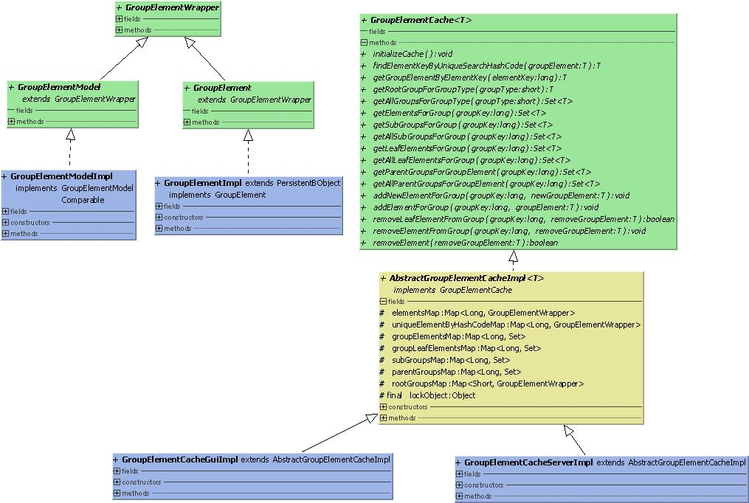
Following diagram show the classes related to the cache implementation.

There are two hierarchies in the above class diagram. One is the actual cache implementation hierarchy and other is the object hierarchy that gets cached.

Class Name | Description
GroupElementCache | Base interface defines all the common methods required for the cache implementation to use. Cache is accessed always using this interface.
AbstractGroupElementCacheImpl | Abstract class implements the common method required for the cache. Most of the getters, cache updates such as adds and removes are implemented here.
GroupElementCahceGuiImpl | GUI layer implementation of the cache extending the AbstractGroupElementCacheImpl.
GroupElementCacheServerImpl | Server layer implementation of the cache extending the AbstractGroupElementCacheImpl.
GroupElementWrapper | The base object class used by the common code in AbstractGroupElementCacheImpl. All the operation in abstract class is implemented using this object.
GroupElement & GroupElementImpl | Domain object implements GroupElementWrapper. On server side this domain objects are cached.
GroupElementModel & GroupElementModelImpl | GUI side model object used for implements GroupElementWrapper. On GUI layer this model objects are cached.

